Day 2 Practice Problems

goo.gl/iS2DYC

Day 2 slides:

<https://drive.google.com/file/d/13OKTksdsnofIC19geJ4LgjxX_cTKewGX/view?usp=sharing>

Day 1 slides:

<https://docs.google.com/presentation/d/1o9v54sHuMZZuQ1PzRWdRR3uw_YnOU2uYZ1MzRncP8wY/edit?usp=sharing>

Write a program that calculates the area of a rectangle (Formula: area = length \* width).

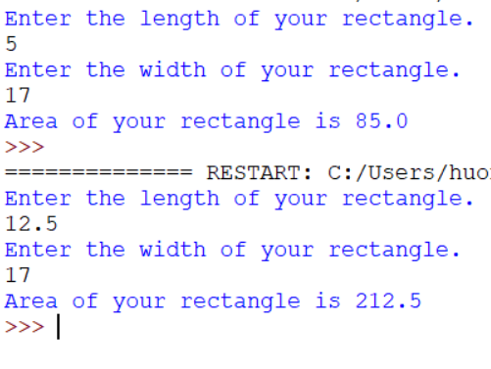

Write a program that prompts the user for the radius of a circle and calculates the area of that circle and prints it out. (Formula: Area = pi\*radius\*\*2)

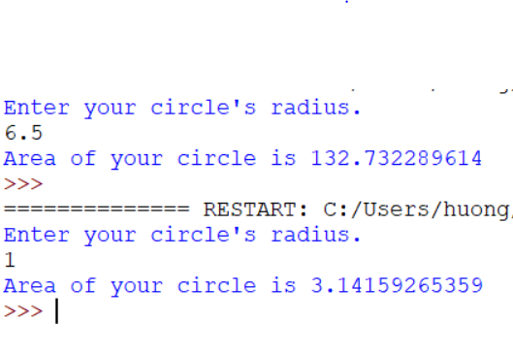

Write a program that prompts the user for the area of a circle and calculates the radius of that circle and prints it out. (Hint: You’ll need to solve the above formula for radius.)

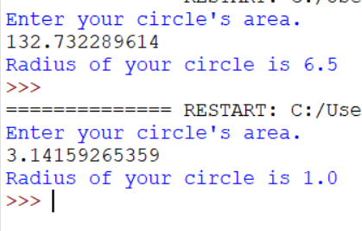

Write a program that asks the user to enter a temperature in Fahrenheit (a float) and prints out the converted value in Celsius. The formula for conversion is C = 5(F – 32)/9.0

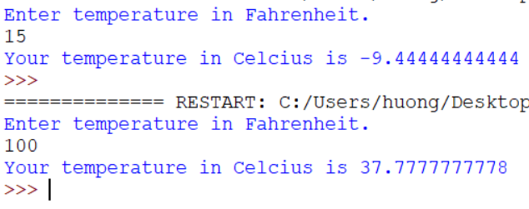

Write a program that asks the user to enter a temperature in Celsius (a float) and prints out the converted value in Fahrenheit. (Hint: You must solve the above formula for F)

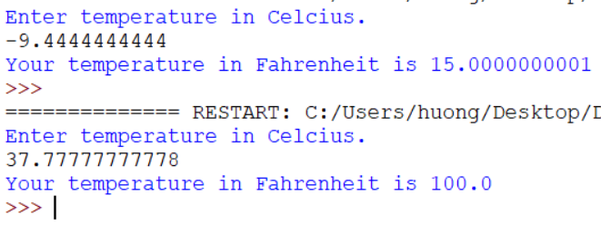

Write a program that asks the user for the number of grams of protein, carbohydrates and fat in their food and prints out the number of calories in that food. (There are 4 calories per gram of protein, 4 calories per gram of carbohydrates, and 9 calories per gram of fat.)

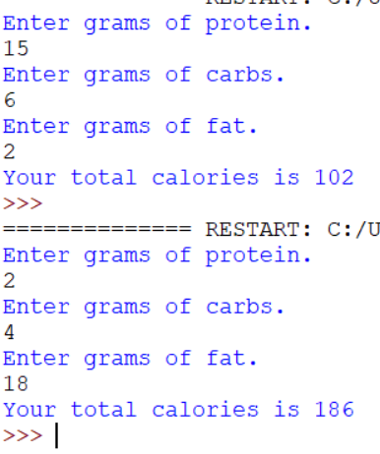

Write a program that asks the user for the length of their road trip in miles (float) and their average speed of driving in miles per hour (float) and prints out how many hours the trip will take.

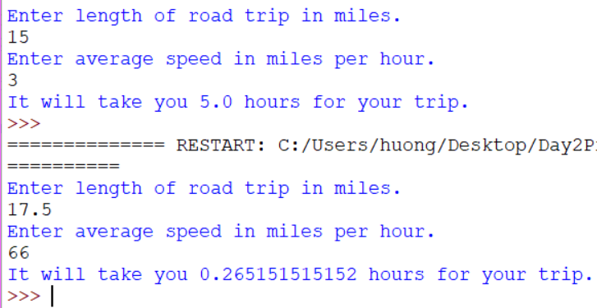

Repeat the program above but print out the number of minutes the trip will take.

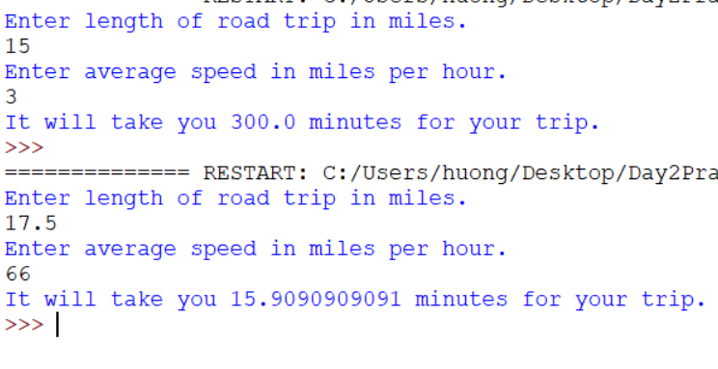

Write a program that asks the user for the price of gasoline per gallon, the number of gallons of gas currently in their car, the miles per gallon their car gets, and the length of their road trip in miles and calculates and prints out the amount the user will have to spend on extra gas to complete the road trip. (You may assume that the user will have to buy some gas to complete the trip.)

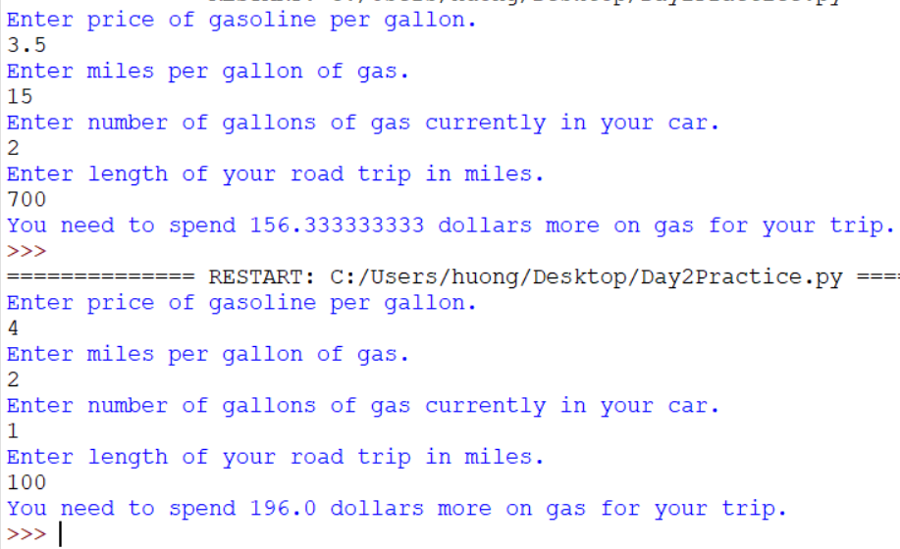

Write a program that prompts the user to enter two points [(x1, y1), (x2, y2)] on the Cartesian plane with different x coordinates and calculate and output the slope between the two points. You may assume this slope is not undefined. M = (y2 - y1) / (x2 - x1)

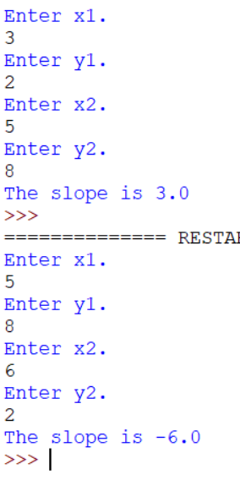

Write a program that asks the user for their hourly pay, the number of hours they work in a week, and the number of weeks they are working in the summer, as well as the cost of a single video game. Output the total number of video games they could buy, if they spent all of their earnings on video games, as well as the leftover money they would have. (The latter value must be strictly less than the cost of a game.) Assume all inputs are integers.

Write a program that calculates the cost of buying season football tickets. Ask the user for the number of upper bowl tickets (these are $25 per game) and lower bowl tickets (these are $50 per game) they desire, followed by the number of games in the season and the sales tax, entered as a percentage. Output the total cost of all the tickets, including tax.

Write a program that calculates the number of pictures that can be stored on a thumb drive. Ask the user to enter the number of gigabytes of data the thumb drive can store, as well as the length and width of each picture, in pixels. Assume that each pixel takes 3 bytes of storage. (This isn’t really the case, since most pictures are stored in a compressed format.) Output your answer as a whole number.